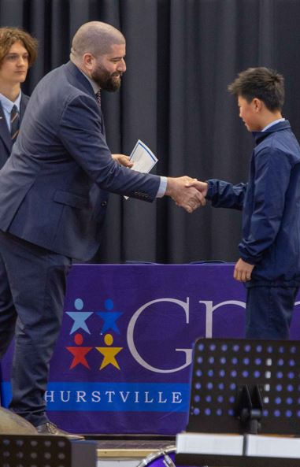

### DE International Contacts

### Telephone: 1300 300 299 (Option 2)

### Email: ssc.dei@det.nsw.edu.au

### Website: www.deinternational.nsw.edu.au

### School Contacts

**School name: Georges River College Hurstville Campus**

**Address: Kenwyn Street**

**Hurstville, NSW, 2220**

**Telephone: +61 2 9587 3199**

**Email:** [hurstville-h.school@det.nsw.edu.au](mailto:hurstville-h.school@det.nsw.edu.au)

**Website: www.hurstville-h.schools.nsw.gov.au**

CRICOS Provider name: NSW Department of Education

CRICOS Provider Code: 00588M

Last updated on 14 October 2024

**INTERNATIONAL STUDENTS ORIENTATION HANDBOOK**

[About the School 4](#_Toc173919357)

[School Profile 5](#_Toc173919358)

[Our Vision 6](#_Toc173919359)

[Our Students 6](#_Toc173919360)

[School Directory 8](#_Toc173919361)

[School Map and facilities 10](#_Toc173919362)

[Support Services 12](#_Toc173919363)

[Rules and Policies 16](#_Toc173919364)

[Bell times 16](#_Toc173919365)

[School Curriculum 21](#_Toc173919366)

[School Activities 23](#_Toc173919367)

[Living in Sydney 25](#_Toc173919368)

[Staying Safe 25](#_Toc173919369)

[Reporting Incidents and seeking help 32](#_Toc173919370)

[You and the Law 34](#_Toc173919371)

[Taking a Part-time Job and Your Work Rights 36](#_Toc173919372)

[Transport and Travel Concession 38](#_Toc173919373)

[Overseas Student Health Cover (OSHC) 39](#_Toc173919374)

[Accommodation 41](#_Toc173919375)

[Visa Requirements You Should Know 46](#_Toc173919376)

[Attendance and Course Requirements 46](#_Toc173919377)

[Accommodation and Welfare Arrangements 47](#_Toc173919378)

[Conditions of Enrolment 48](#_Toc173919379)

[Taking Leave 49](#_Toc173919382)

[Deferment of Course Commencement Date 49](#_Toc173919383)

[Complaints and Appeals 50](#_Toc173919384)

[Arrival Checklist 52](#_Toc173919386)

[Under 18 Request to Change Welfare Arrangements form 53](#_Toc173919387)

[Over 18 Request to Change Welfare Arrangements form 53](#_Toc173919388)

[Leave Request form 53](#_Toc173919389)

[Leave Requests Flowchart 53](#_Toc173919390)

[Leave Requests Flowchart 57](#_Toc173919391)



# About the School

**Principal’s Message**

Dear Students,

Welcome to Georges River College Hurstville Campus!

As you embark on this exciting journey of studying in New South Wales, I want to extend a heartfelt welcome to each of you. Coming to a new country for your education is a significant step, and we are thrilled to have you as part of our school community.

Starting at a new school, especially in a different country, can feel both exciting and a bit overwhelming. Remember, you are not alone in this journey. Our dedicated staff, teachers, and support team are here to help you every step of the way. Please don’t hesitate to ask for assistance whenever you need it. Whether it’s about academic support, navigating school life, or adjusting to a new culture, we are here to ensure you feel comfortable and confident.

Engagement is key to making the most of your time here. I encourage you to actively participate in school activities, join clubs, and attend events. These opportunities will not only enrich your experience but also help you connect with new friends and integrate into our vibrant community.

Your time at GRC Hurstville Campus is a unique opportunity for personal growth, learning, and making lasting memories. Embrace every moment, stay curious, and be open to new experiences. We believe in your potential and are excited to see all that you will achieve during your time here.

Once again, welcome to our school. We are so glad you are here and look forward to supporting you on this exciting journey.

Warm regards,

Kathy Klados

Principal

## School Profile

**Georges River College (GRC), Hurstville Campus** is a comprehensive coeducational school dedicated to supporting students in Years 7-10. Our school works collaboratively with the other schools making up GRC, comprising of Penshurst, Peakhurst, and Oatley Senior campuses as part of a multi-campus college (established in 2001). Students in Years 11 and 12 continue their education at Georges River College – Oatley Senior Campus.

Our focus is on delivering high-quality education through a commitment to excellence in teaching and learning. We tailor our curriculum to meet the diverse educational needs of every student, ensuring they are set up for success.

At GRC, we are proud to offer robust learning programs that target:

* Middle years education
* Literacy and numeracy
* Effective use of technology
* Extension and enrichment for high potential and gifted students

Our dedicated staff work collaboratively to deliver whole-school student welfare programs, empowering students to connect, succeed, and thrive. These programs are built upon the Positive Behaviour for Learning (PBL) values of respect, responsibility, and excellence, which are embedded in every aspect of school life. From the classroom to co-curricular activities, these values ensure that students remain engaged and experience success through a wide range of learning opportunities.

We also provide comprehensive transition programs, ensuring a seamless journey from primary to senior studies and beyond. Our diverse educational facilities include multiple sports grounds, a commercial kitchen, specialist learning spaces, and the advantages of cooperative college opportunities. As a BYOD school, we harness the power of technology to enhance learning across the curriculum.

At Georges River College, Hurstville Campus, we believe in a collaborative approach to continuous improvement. Our evaluative practices draw on reliable data to make informed decisions that strengthen teaching and learning. This data-driven approach ensures that every student can achieve high literacy and numeracy outcomes through high expectations, explicit teaching and differentiated learning

By embedding these evidence-based strategies into our practice, we ensure that every student, teacher, and leader is consistently challenged to grow, improve, and succeed.

## Our Vision

Georges River College (GRC), Hurstville Campus educates young people to become respectful and responsible citizens who are self-motivated, confident, and resilient learners with the skills for future success.

As a middle school, we create a nurturing, inclusive environment that promotes students to strive for excellence and celebrate their success.

We aim to provide each student with a focused and energetic learning environment highly suited to the needs of students and to deliver the best possible education that maximises their personal best.

## Our students

Students at GRC Hurstville Campus come from a diverse range of cultural, linguistic and religious backgrounds.

We currently have:

* + an enrolment of 280 students
  + over 80% students from a non–English speaking background
  + a support unit that caters for students with diverse needs. We have 3 Autism (AU) and 1 AU/IO class.

The school is represented by over 32 countries. The most common languages spoken at the school include English, Arabic, Mandarin and Cantonese. Four students also identify as Aboriginal and Torres Strait Islander (ATSI).

Leadership Raise Program ANZAC Day

STEM Day Music

Rose Assembly

Year 7 Adventure Day

Athletics Carnival Swimming Carnival

## School Directory

### School Staff

|  |  |
| --- | --- |
| **Maria Papageorgiou**  ***International Student Coordinator (ISC)***  Ms. Papageorgiou can speak to you regarding any concerns you may have about your school, health, homestay issues or if you require a leave request or change of address form. She is located in the English/HSIE staffroom in A-Block. | |
|  |  |
| **David Davis**  **Deputy Principal** | **Rachelle Pirie**  **Deputy Principal** |
| **Erin Burgess**  ***School Counsellor***  Ms. Burgess can speak to you if you have concerns, feel unhappy or are homesick. She/he is located in room her office on the ground floor of A-Block. | |
| **Ms Giannarakis**  ***Business Manager***  Ms. Giannarakis can help you if you are trying to find your International Student Coordinator or counselor or need help in the absence of the International Student Coordinator. | |

|  |
| --- |
| ***If you need help with a problem or feel unsafe at school at any time, go and see your International Student Coordinator or one of the staff listed here 😊*** |

**Year Advisers**

Your Year Adviser can speak to you if you have any concerns about your school work.

|  |  |
| --- | --- |
| **Title** | **Staff Member** |
| **Years 7 and 8** | Mr Peckham |
| **Years 9-10** | Ms Fox |

**Head Teachers**

|  |  |
| --- | --- |
| **Title** | **Staff Member** |
| **English/Languages** | Ms Kourouche |
| **HSIE** | Ms Doulakis |
| **Mathematics** | Ms Kang |
| **Administration** | Mr Laverance |
| **Wellbeing** | Mr Rea |
| **Science** | Mr Baker |
| **Special Education** | Ms Amacha |
| **TAS/Visual Arts** | Ms Cazouris |
| **Student Engagement** | Mr Walsh |

**Other Key Staff**

|  |  |
| --- | --- |
| **Title** | **Staff Member** |
| **International Student Coordinator** | Ms Papageorgiou |
| **Sports Coordinator** | Mr Derbridge |
| **Technology Support** | Mr Peckham |
| **Librarian** | Ms Hankinson |
| **Learning and Support Teacher** | Ms Kandylas |
| **Careers Advisor** | Mr Mustapic |
| **Student Support Officer** | Amber Harvie |

## School Map and facilities

|  |  |
| --- | --- |
| **Facility** | **Location** |
| Sick Bay | 3 |
| Counsellors Office | 6 |
| SSO Office | 6 |
| International Student Coordinator | 6 |

Access to the closest train station is via Vine Street.

## Support Services

### Counselling

Ms. Burgess is the School Counsellor and she is located in A Block.

**What is a School Counsellor?**

In all New South Wales government schools, there is a counsellor who is a qualified teacher and educational psychologist with special training to help students with any problems they are having, or to help them get information they may need.

This service is free and confidential.

**Why do students see the Counsellor?**

**Academic problems**

* Worries about progress
* Indecision about staying at school
* No quiet place to study at home

**Personal problems**

* Sadness in missing your country/friends
* Feeling lonely at school
* Home problems such as not getting along with family members
* Feeling anxious about making friends

Students can self-refer to the counsellor using the box found outside her office. Alternatively, they can speak to their Year Advisor or the HT Wellbeing about making an appointment.

### EALD Support

EALD support can be sought from the EALD Teacher Ms. Papageorgiou. Support can also be provided via the Learning and Support Team, or through the Homework Centre.

### Year Advisers

The main role of the Year Adviser is to identify the needs of and provide support to individual students. Year Advisers strive to resolve student difficulties and to ensure the most appropriate outcomes for the students. They encourage students to participate in a range of activities and develop their leadership skills.

Year Advisers are available for both parents and students if there is a wellbeing concern. Where possible the Student Advisers will remain with their students from Year 7 to Year 10 providing continuity for students.

**Head Teacher Wellbeing**

The Head Teacher Wellbeing is responsible for leading the wellbeing team and supporting a wide variety of student wellbeing programs across the school.

**Career Advisers**

Students are given personalised advice, based on their interests and strengths to:

* choose appropriate subjects in years 11 and 12
* explore possible learning pathways through TAFE
* explore future careers via careers expositions and College-wide programs.

This involves 1:1 meetings with careers advisors to support the ongoing program of careers development.

### Homework Centre

Homework Centre is available for all students to attend and is run by members of the teaching staff to assist students to complete work. The Homework Centre is open after school between 3 – 4pm on Monday.

### Our School Library

Our library is well-resourced with technology and physical books specifically targeted to the interests and reading levels of our students. Spaces are created purposefully to support a range of learning modes, including:

* explicit teaching
* discussion
* collaboration
* independent learning
* modelled learning
* experiential learning.

Software is used to support effective library use including:

* Oliver - software for managing, recommending and loaning resources
* ePlatform - an online library for borrowing eBooks and Audiobooks
* Maths Pathway – an online platform for mathematics that provides targeted and differentiated learning

### Transition to Senior High School

Transition programs to Oatley Senior Campus for students in Year 10 transitioning into Year 11 participate in orientation days.  Transition Advisors coordinate these programs to ensure the smooth transfer from one educational setting to the next across GRC.

### High Potential and Gifted Students

High Potential and Gifted students are supported to develop their full academic and creative potential.

### CO-CURRICULAR EXPERIENCES

**Student Leadership**

Student leadership opportunities are available to all students through:

* A pair of boys sitting outside

  Description automatically generated with medium confidenceSRC leadership
* Peer Support Leaders
* Peer Mediators
* Peer Tutors
* House Captains

**Clubs and Experiences**

Additional learning and wellbeing opportunities provided to students include:

* Chess Club
* Band
* Creative Writing Workshops
* Gym Club
* Debating – 2023 Finalists in the Premiers Debating Challenge for both Junior and Senior Team
* Public Speaking
* TRIBE

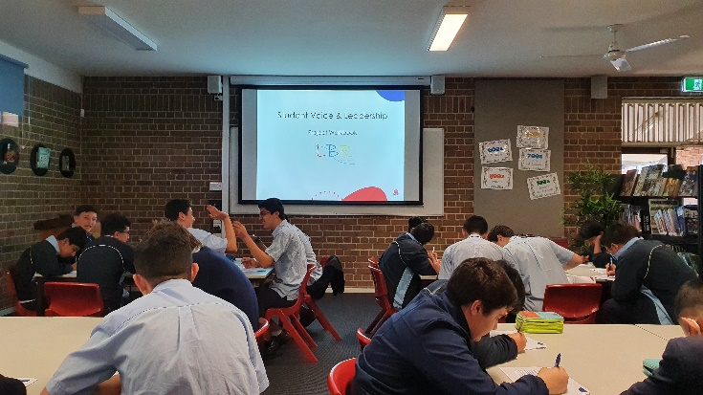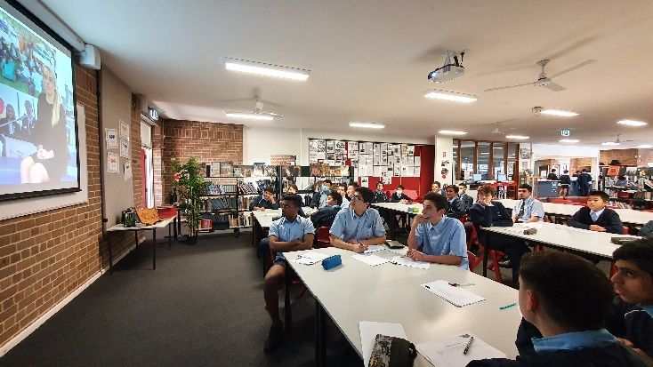

**Year-Group Specific Development**

HELP (Hurstville Essential Learning Period) is conducted each morning, Monday to Thursday for 30 minutes. Each cohort has a targeted area of development:

* Year 7 and 8 have a focus on literacy and numeracy. Programs have been developed by a team of staff who have analysed achievement data for all students and designed the literacy and numeracy programs to target identified areas of need.
* Year 9 have a cardiovascular endurance focus for the year to improve brain functioning, learning behaviour and mental health based on successful overseas research. They also start exploring their potential career pathway.
* Year 10 students participate in a program designed to suit their future pathway:
  + transition to Oatley Campus
  + school to university
  + school to work
  + a combination of the above.

**Rules and Policies**

**Bell times**

|  |  |  |  |  |  |  |  |  |  |  |  |
| --- | --- | --- | --- | --- | --- | --- | --- | --- | --- | --- | --- |
|  | | | | | | | | | | | |
| **Monday/Tuesday** | | | **Wednesday** | | | **Thursday** | | | **Friday** | | |
| Warning Bell | 8:25 | | Warning Bell | 8:25 | | Warning Bell | 8:25 | | Warning Bell | 8:25 | |
| **Roll Call/ HELP** | **8:30** | **9:00** | **Roll Call/ HELP** | **8:30** | **9:00** | **Roll Call/ HELP** | **8:30** | **9:00** | **Year Meetings/**  **Assembly** | **8:30**  **8:30** | **9:15** |
| Period 1 | 9:00 | 9:57 | Period 1 | 9:00 | 10:00 | Period 1 | 9:00 | 9:54 | Period 1 | 9:15 | 10.09 |
| Period 2 | 9:57 | 10:54 | Period 2 | 10:00 | 11:00 | Period 2 | 9:54 | 10:48 | Period 2 | 10.09 | 11.03 |
| **RECESS** | **10:54** | **11:24** | **RECESS** | **11:00** | **11:30** | **RECESS** | **10:48** | **11:18** | **RECESS** | **11.03** | **11:33** |
| Period 3 | 11:24 | 12:21 | Period 3 | 11:30 | 12:30 | Period 3 | 11:18 | 12:12 | Period 3 | 11:33 | 12:27 |
| Period 4 | 12:21 | 1:18 | Period 4 | 12:12 | 1:06 | Period 4 | 12:27 | 1:21 |
| **LUNCH** | **1:18** | **1:48** | **LUNCH** | **12:30** | **1:00** | **LUNCH** | **1:06** | **1:36** | **LUNCH** | **1:21** | **1:51** |
| Period 5 | 1:48 | 2:45 | Period 4 | 1:00 | 2:30 | Period 5 | 1:36 | 2:30 | Period 5 | 1:51 | 2:45 |
|  | | | EXECUTIVE MEETINGS | | | STAFF/ACTION TEAM MEETINGS | | |  | | |
| 57 minute periods | | | 60 minute periods | | | 54 minute periods | | | 54 minute periods | | |

**School Uniform**

GRC Hurstville Campus is a uniformed school and all students are expected to be in school uniform each day. Wearing the school uniform helps the to develop pride in their school and allows them to be viewed favourably by the community. We have a strict shoes and footwear policy to comply with safety requirements.

Uniforms are available from Lowes, Hurstville and Roselands.

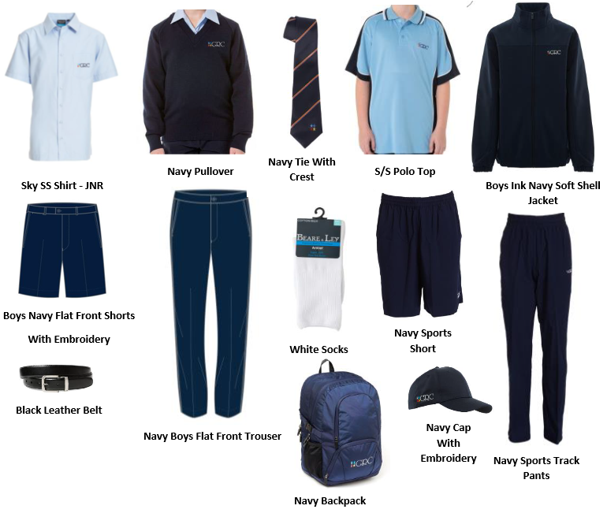

### Policies and procedures on absences, lateness or leave requests

Students are required to inform the school if they are not able to attend school via the following ways:

**SMS** - In the event of an absence, an SMS text message will be automatically sent to the mobile phones of parents explaining that our records show that your child is absent from school.

**Absence Explanation** - An absence note that is dated and signed by the student’s parent/guardian should state the student’s name, roll class and give the reason for student absence. This must be sent to school within 3 days of your son’s return to school.

**Late Arrivals** - Students should only arrive late for school if there has been an unavoidable situation. Students arriving late must sign in at the Student Attendance Office (back office) and have a signed note from a parent explaining the late arrival.

**Early Leavers** - Students requiring an early leave pass must bring a note from the parent/caregiver. The note should clearly state the name of the student, the reason leave is requested, the time of leaving and be signed and dated by the parent or caregiver. The early leave is then approved by the Deputy Principal before 8:15am and recorded on the Attendance System. Medical and dental appointments should be made out of school time, including Wednesday afternoon sport time as well as providing a medical appointment card.

### Attendance requirements for student visa holders

* All students are expected to attend class every school day.
* International students are on a student visa and have additional attendance requirements as a condition of your student visa.
* International students must attend at least 80% of classes each term or you may be reported to the Department of Home Affairs.

### What if my attendance falls below 80%?

* A **warning letter** will be sent to you, your parents and your carer in Australia.
* You will have to attend an interview and explain why you have been away.
* If you have any supporting documentation such as **medical certificates**, present them as evidence.
* Your attendance will continue to be closely monitored. If your attendance does not improve, you will be sent a **second and final warning letter.**

### What if my attendance falls below 80% over two terms, or below 60% in one term?

* An **Intention to Report** letter will be sent to you, your parents and your carer in Australia. This letter tells you the school’s intention to report your low attendance to the Department of Home Affairs because you have breached your student visa condition.
* You will be given 20 school days to **appeal** to the Principal and explain why the school should not report you to the Department of Home Affairs.
* The school will inform you of the appeal outcome and if unsuccessful, your outcome letter will provide information on how to access the external appeals process through the NSW Ombudsman.
* If all your appeals are not successful, you will be reported to the Department of Home Affairs and they may decide to cancel your visa.

### Policy on misbehaviour, suspension and expulsion

At GRC HC students are expected to:

* show respect to other students, their teachers and school staff and community members
* follow school and class rules and follow the directions of their teachers
* strive for the highest standards in learning
* act in a courteous and respectful way that makes all members of the school community feel valued, included and supported
* resolve conflict respectfully, calmly and fairly
* meet the school’s agreed uniform policy or dress code
* attend school every day (unless legally excused)
* respect all property
* be safe and not be violent or bring weapons, illegal drugs, alcohol, vapes, e-cigarettes or tobacco into our schools
* not bully, harass, intimidate, or discriminate against anyone in our schools

As a Positive Behaviour for Learning School, students are expected to display our core values of Respect, Responsibility and Aiming for Excellence at all times. If a student is not meeting these expectations there will be consequences such as reflections, and you may need extra supports from staff that are detailed in contracts with a Classroom Teacher, a Head Teacher or a Deputy Principal. These supports may include seating plans, individual reminders of expectations and/or reduced access to some activities.

There may be cases of unacceptable behaviour where a student may need to be removed from the school for a period of time. Suspension is an action available to the school in these situations. The purpose of the suspension is to allow the school to implement appropriate supports during the student’s absence to address the student’s complex and challenging behaviour or behaviours. This is to ensure a successful return to school, and mitigate any unacceptable risks posed to teaching and learning, and the health, safety and wellbeing of staff and/or students.

**Suspension and expulsion**

International students will be reported to the Department of Home Affairs if they are:

* suspended for 5 days or more;
* expelled from school because of serious misbehaviour/ involvement in criminal activities.

**What happens if I am suspended for 5 or more days from school?**

* You will be given an **Intention to Report** letter and will be given 20 school days to appeal to the Principal and explain why you should not be reported to the Department of Home Affairs.
* If your appeal is unsuccessful, you will be advised of your further rights on how to access the external appeals process through the NSW Ombudsman.
* If all your appeals are unsuccessful, your suspension will be reported to the Department of Home Affairs and they may decide to cancel your visa.

**What happens if I am suspended for 5 or more days from school for behaviour that is likely to put at risk my own health or wellbeing, or the wellbeing of others?**

Examples of when wellbeing is at risk includes but is not limited to, when you:

* refuse to maintain approved care arrangements, if you are under 18 years of age;
* are missing;
* have medical concerns, severe depression or psychological issues which lead DE Internatioanl to fear for your wellbeing;
* have engaged or threaten to engage in behaviour that is reasonably believed to endanger yourself or others; or
* are at risk or commit a criminal offence.
* You will be given an **Intention to Report** letter and your enrolment may be terminated

**What happens if I am expelled from school?**

* You will be given a letter of **Notice of Enrolment Termination** following your expulsion and be reported to the Department of Home Affairs who may decide to cancel your visa.

**Student Behaviour**

GRC Hurstville Campus is committed to providing safe, supportive and responsive learning environments for everyone. We teach and model the behaviours we value in our students. The school works with its community to provide quality learning environments which are:

* inclusive.
* safe and secure.
* free from bullying, harassment, intimidation and victimisation.

Students are expected to follow the Behaviour Code for Students and Management Plan and school rules and to comply with staff directions regarding appropriate behaviour.

GRC Hurstville Campus has:

* the Student Behaviour Support and Management Plan.
* Positive Behaviour for Learning (PBL) Framework that promotes positive student behaviour, including specific strategies to maintain a climate of respect.
* Student Reward system including school merits and Do the Right Thing Award (DRTA)
* Strategies and practices to manage inappropriate student behaviour.

## School Curriculum

**School Curriculum Structure for Year 7 -10**

Our school provides a comprehensive curriculum which caters for the diverse learning needs of all students.

**Mandatory Courses Years 7 and 8**

* English
* Mathematics
* Science
* Human Society and its Environment – History and Geography (HSIE)
* Personal Development, Health and Physical Education (PDHPE)
* Technology and Applied Sciences (TAS)
* Languages other than English (LOTE)
* Creative and Performing Arts – Music, Visual Arts (CAPA)
* Sport
* Literacy and Numeracy Program
* Reading Renaissance Program

In Year 8 students choose elective subjects to study in Years 9 - 10.

**RECORD of School Achievement (RoSA)**

Students continue their study of the core subjects:

* English
* Mathematics
* Science
* Australian History, Australian Geography, Civics and Citizenship
* Personal Development, Health and Physical Education

 In addition, students select three electives (100 & 200 hours) in Year 9 and continue two electives (200 hours) into Year 10. The following courses are currently offered as electives:

|  |  |
| --- | --- |
| **Year 9** | **Year 10 (200 hours)** |
| Agricultural Technology (100 hrs) | Commerce |
| Commerce (100 & 200 hrs) | English for Success |
| Food Technology (200 hrs) | Industrial Technology - Engineering |
| French (100 hrs) | Industrial Technology - Timber |
| History (200 hrs) | Computing Technology |
| Industrial Technology - Timber (200 hrs) | Music |
| Industrial Technology - Engineering (200 hrs) | Physical Activity and Sports Studies |
| Computing Technology (200 hrs) | Visual Arts |
| Music (200 hours) | Work Education |
| Photography & Digital Media (100 & 200 hrs) |  |
| Visual Arts (100 & 200 hrs) |  |
| Work Education (100 & 200 hrs) |  |

These electives are determined yearly based on student demand.

After Year 10 students graduate to Oatley Senior Campus.

All students receive specific information regarding assessments and the procedures that GRC HC uses to support student achievement in a separate booklet. Year 10 students will receive more information on the ‘N’ warning process, and requirements for the RoSA in a separate booklet.

### Course progress requirements for student visa holders

There are additional course progress requirements for international students.

* If you fail to meet the NSW Education Standards Authority’s (NESA) course progress requirements for 50% or more of all your units (e.g. 6 out of 12 units), an Intention to Report letter will be sent to you, your parents and your carer in Australia. This letter tells you the school’s intention to report your unsatisfactory course progress to the Department of Home Affairs because you have breached your student visa condition.
* You will be given 20 school days to **appeal** to the Principal and explain why the school should not report you to the Department of Home Affairs.
* If your appeal is unsuccessful, you will be informed on how to access the external appeals process through the NSW Ombudsman in your outcome letter.
* If all your appeals are not successful, you will be reported to the Department of Home Affairs and they may decide to cancel your visa.

## School Activities

**Co-Curricular Experiences**

**Student Leadership**

Student leadership opportunities are available to all students through:

* SRC leadership
* Peer Support Leaders
* Peer Mediators
* Peer Tutors
* House Captains

**Clubs and Experiences**

Additional learning and wellbeing opportunities provided to students include:

* Chess Club
* Band
* Creative Writing Workshops
* Gym Club
* Debating – 2023 Finalists in the Premiers Debating Challenge for both Junior and Senior Team
* Public Speaking
* TRIBE.



**Homework Centre**

Homework Centre is available for all students to attend and is run by members of the teaching staff to assist students to complete work. The Homework Centre is open after school between 3 – 4pm on Mondays.

**Hurstville Essential Learning Period (HELP)**

HELP (Hurstville Essential Learning Period) is conducted each morning, Monday to Thursday for 30 minutes. Each cohort has a targeted area of development:

* Year 7 and 8 have a focus on literacy and numeracy. Programs have been developed by a team of staff who have analysed achievement data for all students and designed the literacy and numeracy programs to target identified areas of need.
* Year 9 have a cardiovascular endurance focus for the year to improve brain functioning, learning behaviour and mental health based on successful overseas research. They also begin to explore potential career pathways.
* Years 10 students participate in a program designed to suit their future pathway:
  + transition to Oatley Campus
  + school to university
  + school to work
  + a combination of the above.

# Living in Sydney

## Staying Safe

### Emergency Services

**Ambulance, Police or Fire Brigade**

|  |  |
| --- | --- |
| **L:\DEI - International Students\Student Support and Compliance\Orientation Booklet\Images\emergency.jpg** | **In case of an emergency or if you are in danger,**  **call 000 and tell them:**   * Type of emergency (ambulance/police/fire brigade) * Your location or location of the emergency * Your full name and contact number (if possible) |
|  |  |
| **L:\DEI - International Students\Student Support and Compliance\Orientation Booklet\Images\police station.jpg** | **The local police station is Hurstville Police Station**  **Address:** 36-38 Ormonde Pde  Hurstville New South Wales 2220  **Phone:**[**(02) 9375 8599**](tel:0293758599) |
|  |  |
| **L:\DEI - International Students\Student Support and Compliance\Orientation Booklet\Images\medical centre.jpg** | **The nearest medical centre is Hurstville Medical Centre**  **Address: 1**85 Forest Rd,  Hurstville New South Wales 2220  **Phone:** [**(02) 9580 7233**](tel:0295807233) |
|  |  |
| **L:\DEI - International Students\Student Support and Compliance\Orientation Booklet\Images\hospital.jpg** | **The nearest hospital to the school is: St George Hospital**  **Address:** Gray Street KOGARAH NSW 2217  **Phone:(02) 9113 1111** |

### Homestay 24 Hour Hotline

**If you are living in a homestay or with a parent nominated carer** (distant relative or a close family friend), you can talk to your carer that you are registered with if you need help.

Alternatively, you may wish to contact the homestay company that your carer is registered with on their 24 hour hotline. Contact your International Student Coordinator if you do not know the name of your carer’s registered homestay company.

|  |
| --- |
| **Auzzie Families Homestay Care**  Contact: Ms Gloria Wang  Phone: (+61 2) 8328 8499  Mobile: 0419 628 168 (24 hours)  Email: [info@auzziefamilies.com](mailto:info@auzziefamilies.com)  Website: [www.auzziefamilies.com](http://www.auzziefamilies.com/)  **Oz Homestay**  Contact: Ms May Yung  Phone: (+61 2) 9325 6988  Mobile: 0421 556 374 (24 hours)  Email: [info@ozhomestay.com.au](mailto:info@ozhomestay.com.au)  Website: [www.ozhomestay.com.au](http://www.ozhomestay.com.au/)  **Global Experience**  Contact: Ms Agnes Ong  Phone: (+61 2) 9264 4022  Mobile: 0430 008 448 (24 hours)  Email: sydney@globalexperience.com.au  Website: [www.globalexperience.com.au](http://www.globalexperience.com.au) |

### Important Safety Tips

When you are out with friends or by yourself, here are some simple things to remember:

|  |
| --- |
| **Did you know?**  You must let your school know of **any change of your address and contact details as soon as possible, no later than 7 days**.  This is a student visa requirement and helps to keep you safe if the school knows where you live and how to contact you in case of an emergency. |

* Always **plan your trip** home, especially at night. You may want to pre-book a taxi/Uber or arrange transport with a friend. Always make sure you have enough money to get home.
* **Avoid staying out past 8pm**.
* If you have a part-time job, **do not work during school nights** Monday – Thursday and return home by 9pm on weekends.

*Note: Students must have been enrolled for at least 6 months in high school before working, and must provide a letter of consent from their parents. IEC students are not eligible to work.*

* Try to **travel with a friend** or in a group at night.
* **Keep your bag** and belongings **close to your body** and where you can always see them.
* **Leave valuables at home** if you don't need to take them with you. This includes jewellery, electronic equipment such as your laptop and your passport.
* **Do not carry large amounts of money** with you. The majority of retailers accept electronic payment through cards or payment systems on your phone. You can take money out at ATMs found in shops, supermarkets, petrol stations, shopping malls, shop fronts and many other public places.
* **Do not accept parcels** that do not directly belong to you. You will be held legally responsible for the contents of the parcels.
* **Do not pay for school fees through people who offer discounts.** This is a SCAM.
* **Call 000 in the event of an emergency**. Remember, calls to 000 are free of charge.

### Cyber Safety

When using the internet, like anywhere in the world, you should protect yourself against spam, online scams, identity theft and online bullying. Protect yourself by following these tips:

* If you are using a public computer, make sure you **log out of your online** **accounts** such as your social media account, bank or email accounts, and log out of your computer account before you walk away.
* 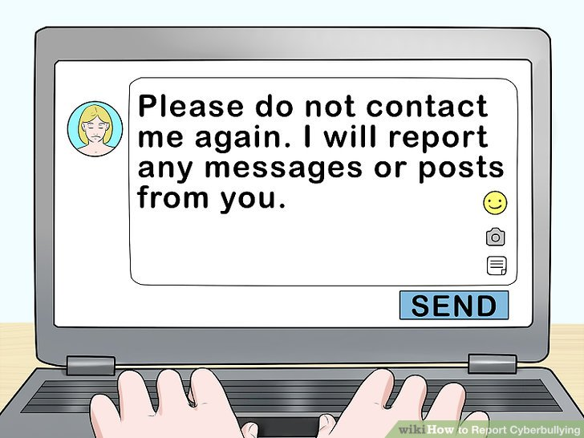**Do not give away your personal information**. This includes your name, phone number, address, email address, date of birth, usernames and passwords, and bank details.
* If you think you’re being harassed or bullied online, **report the person being abusive** to the website or social media administrators and talk to someone you trust straight away — such as a parent, ISC/teacher or friend, or contact [**Kids Helpline**](https://kidshelpline.com.au/kids/get-help/webchat-counselling/?referrer='acma') **(1800 55 1800)**
* **Ignore, block or mute** the person being abusive online and do not engage with them

|  |
| --- |
| ***You can find more information on the Kids Helpline website at:***  [***https://kidshelpline.com.au/teens/issues/online-harassment***](https://kidshelpline.com.au/teens/issues/online-harassment) |

### Road Safety and Public Transport Safety

* 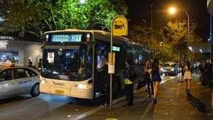Where available, use pedestrian walkways and only cross the street at pedestrian crossings or lights.
* Watch for traffic before you cross by looking left and right for oncoming cars.
* Do not use your mobile phone or put on your earphones when you are crossing the road.
* Avoid isolated bus, ferry, rail and light rail stops.

Public transport is reliable and widely used in Australia, particularly in metro and urban areas. A number of security measures have been implemented to maximise the safety of public transport users including security officers and guards, help points, good lighting and security cameras. However, you should still use caution whenever travelling on public transport:

* Check transport timetables to avoid long waits, particularly at night. You can download an app on your mobile phone such as **TripView, TripGo or NextThere** to view timetables of public transport and plan your trip. Visit <https://transportnsw.info/apps> for all the apps available to help you plan your trip.
* If you find yourself left in a train carriage on your own or with only one other person you may feel more comfortable moving to another carriage closer to the guard or driver.

|  |
| --- |
| ***Train carriages nearest to the driver or guard have a blue light on it and are safest at night.*** |

### Safety Apps



The **Emergency Plus app** is a national emergency app that you can use to get help as soon as possible in an emergency situation.

It tells you the exact location on the map and the GPS coordinates that you can read to the operator when you call the emergency service.

**Water Safety**

* Check whether a beach is closed before you go. Closed beaches are not patrolled and signal dangerous conditions.
* Only **swim between the red and yellow flags** on the beach. This is the area where lifeguards and lifesavers patrol to keep you safe.   
  No Flags = No Swim
* Look for, read and **obey water safety signs.**
* **Never swim alone** at the beach.
* Check water conditions and water depth before swimming – never dive head first.
* Never bathe and swim directly after eating or under the influence of drugs including alcohol.
* Learn how to spot a **rip current** and keep clear of the area.
* Always **use sunscreen** to protect exposed skin, put on a shirt, wear sunglasses and a hat when not swimming, and drink plenty of water.

**Spot and Survive a rip current**

Rip currents are the number one hazard on Australian beaches. The things to look for are deeper, dark-coloured water; fewer breaking waves; a rippled surface surrounded by smooth waters; and anything floating out to sea or foamy, discoloured, sandy, water flowing out beyond the waves.

If you are caught in a rip: **stay calm, float with the current, call out HELP** and **raise an arm** to gain attention of nearby surfers or lifeguards.

**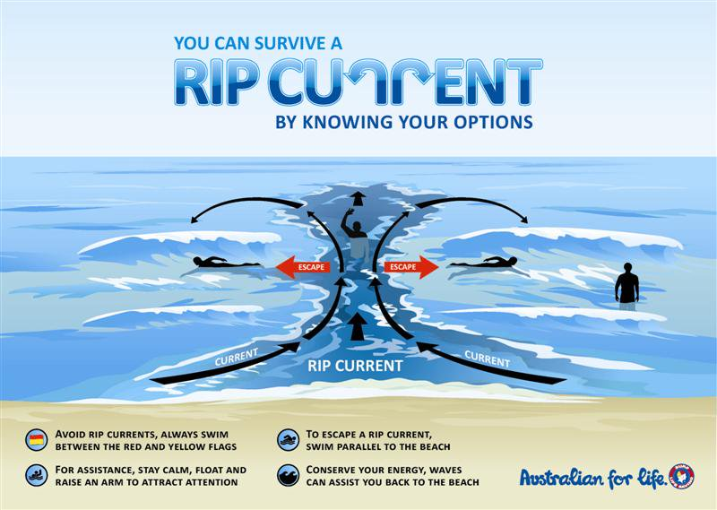**

|  |
| --- |
| Learn about how to spot a **rip** and what to do when you are caught in a rip from the videos (multi-languages) on the **Beachsafe** website: <https://beachsafe.org.au/surf-safety/ripcurrents> |

## Reporting Incidents and seeking help

Bullying, assaults and harassments of any form is not tolerated in Australia. If you have experienced any form of assault (either sexually or physically), harassment or any abuse, or think you are in danger of being assaulted, use the following services:

|  |
| --- |
| 1. **If you are in immediate danger or wish to report an incident:**   ***Police/Ambulance/Fire Brigade at 000*** |

1. If you need help at school:

* Your **International Student Coordinator** Maria Papageorgiouat A Block
* **School Counsellor** Erin Burgess at A Block

1. If you are concerned for your safety, and you feel you need to speak to someone for support, or for information on any support services that you can use:

* **Kids Helpline** is a free, private and confidential 24/7 phone line and online counselling service for young people. Call **1800 55 1800** or email[**counsellor@kidshelpline.com.au**](mailto:counsellor@kidshelpline.com.au)or visit[**www.kisdshelpline.com.au**](http://www.kisdshelpline.com.au)for more information**.**

* **Bullying. No Way!** provides information and helpful ideas about bullying: [**https://bullyingnoway.gov.au/**](https://bullyingnoway.gov.au/)
* **1800RESPECT** is a confidential information, counselling and support service for sexual assault victims and domestic violence.

Call 1800 737 732 (24 hours) or visit their website at [**www.1800respect.org.au**](file://oxvdata4.central.det.win/deci_data6/dei%20-%20international%20students/Student%20Support%20and%20Compliance/Orientation%20Booklet/www.1800respect.org.au) Ask for an interpreter if you wish to speak in your own language that is not English.

****

**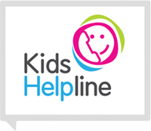**

## You and the Law

The laws in Australia can be very different from your home country.

For example:

|  |
| --- |
| * it is illegal to ride a bike without wearing a helmet * it is illegal to ride an e-scooter in NSW * it is illegal to purchase and consume alcohol if you are under 18 years of age * it is illegal to purchase and smoke cigarettes/vapes if you are under 18 years of age * possession and use of illegal drugs is a criminal offence * it is illegal to use a mobile phone whilst driving |

Visit the website [www.lawstuff.org.au](http://www.lawstuff.org.au) for information about laws relating to you.

### Driving

You need to be at least 16 years old to be a Learner (L Plater) for driving a car. For car drivers, you can attempt a Driving Test to get your P1 (red) licence once you have turned 17 and you:

* have been on your L’s for at least 12 months
* have logged at least 120 hours driving time which includes 20 hours night-time driving.

**If you are driving a car on a Learner (yellow) or P1 (red) licence:**

* You must not drive faster than 90 km per hour
* You must have a zero blood alcohol limit
* You must not use any functions of a mobile phone including hands-free devices while driving.
* You must not drive with more than one**passenger** under 21 between the hours of 11pm and 5am.



**If you are driving a car on a P2 (green) licence:**

* You must have a zero blood alcohol level
* You must not exceed a maximum speed limit of 100 km/h

|  |
| --- |
| ***C:\Users\tlaw5.CENTRAL\AppData\Local\Microsoft\Windows\Temporary Internet Files\Content.IE5\OU3K927D\70px-Exclamation_mark_red[1].png***   * ***Driving without a licence or using a mobile phone while driving is illegal*** * ***Seatbelts are compulsory for drivers and passengers in Australia.*** * ***Speeding and drink driving are dangerous and are against the law.*** * ***You could lose your licence or go to jail if you are caught speeding or drink driving.*** |

## Taking a Part-time Job and Your Work Rights

### Allowable Work Hours

In order for you to work part-time, you **MUST**:

* Not be enrolled in an Intensive English Program
* have been enrolled for at least six months in your current high school
* have a satisfactory attendance record
* provide your school with a letter of consent from your parents.

|  |
| --- |
| ***Students enrolled in an Intensive English Program are not permitted to work.*** |

If you are taking a part-time job, remember:

* Any part-time work during school term must not interfere with your school studies
* You must NOT work more than 40 hours per fortnight (14 days) which is a mandatory student visa condition
* You should not work more than 10 hours per week in school terms
* You should not work during school days (Monday – Thursday) as this may impact on your learning
* You should not work past 8pm during the weekend.

**Tax File Number**

You must obtain an Australia Tax File Number (TFN) in order to work part-time. Your TFN is your personal reference number in the Australian tax system and you will be asked to provide your TFN to your employer at the workplace. If you do not have a TFN, you will be taxed at a higher rate.

You can apply for a TFN online at the **Australian Taxation Office** website at [www.ato.gov.au](http://www.ato.gov.au).

**Know Your Work Rights**

**Workplace rights**

Pay rates and workplace conditions are set by Australian law. All people working in Australia, including those from overseas, have rights and protections at work. These cannot be taken away by contracts or agreements. These rights protect:

|  |
| --- |
| ***Getting help to resolve a workplace issue will NOT automatically affect your student visa.*** |

* entitlement to a minimum wage and superannuation
* challenge of unfair dismissal from the job
* leave, breaks and rest periods
* a healthy and safe work environment

If you have questions about your pay and conditions while in Australia, you can contact the **Fair Work Ombudsman** for free information, resources and advice.

Visit [**www.fairwork.gov.au**](http://www.fairwork.gov.au)for information for visa holders and international students. This includes information in 27 languages. There are also a range of helpful videos available at [www.youtube.com/fairworkgovau](http://www.youtube.com/fairworkgovau) about working in Australia in many languages.

You can also contact the Fair Work Ombudsman by phone within Australia on **13 13 94 (Translating and Interpreting Service 13 14 50)**.

**Pay**

Your minimum pay rate can come from an award, enterprise agreement or other registered agreement, or the national minimum wage. Employees have to be paid the right pay rate for all hours they work including training, team meetings, opening and closing the business and doing a trial shift.

**National minimum wage**

Certain employees may have different pay entitlements depending on whether they have a reduced work capacity because of disability, if they are under the age of 21 or if they are an apprentice or trainee. You can calculate your correct pay and entitlements using the Pay and Conditions Tool at [www.fairwork.gov.au/pay](http://www.fairwork.gov.au/pay)

More information on employment in Australia is available on our website at [www.homeaffairs.gov.au](http://www.homeaffairs.gov.au) and on the website of the Department of Employment at [www.dewr.gov.au](http://www.dewr.gov.au)

|  |
| --- |
| ***C:\Users\tlaw5.CENTRAL\AppData\Local\Microsoft\Windows\Temporary Internet Files\Content.IE5\OU3K927D\70px-Exclamation_mark_red[1].pngAlways ask for a payslip to keep track of your hourly rate, penalty rates, superannuation contributions and tax details, especially if you are getting paid with cash in hand. This is a mandatory requirement for an employer in Australia.*** |

## Transport and Travel Concession

**Children 4 to 15 years of age** are entitled to a child’s half fare concession. School students from the age of 4 to **16 years of age and older** are entitled to a half fare concession.

In order to travel on public transport at concession fares, you must carry a **NSW Transport Concession Entitlement Card** (previously known as the Proof of Age card for children 4 to 15 years, Senior Secondary Student Concession Card for 16 years and over, and Mature Secondary Student Concession Card for 18 years and over).

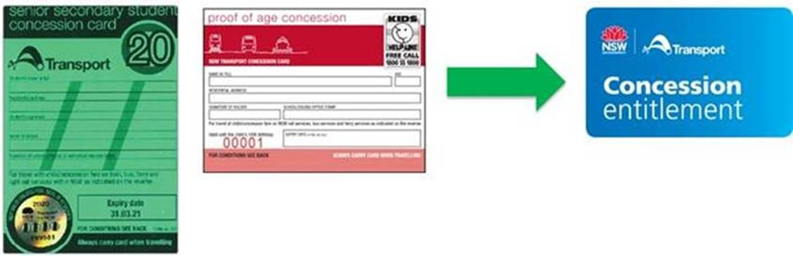

|  |
| --- |
| ***Please see your office staff to apply for a Transport Concession Entitlement Card before you get a Child/Youth Opal Card. You must carry this card with you at all times and present it to ticket inspectors when required.*** |

**Opal card** is the smartcard ticketing system used to pay for travel on public transport in Sydney, the Blue Mountains, Central Coast, the Hunter and the Illawarra.

You should get a **green CHILD/YOUTH OPAL CARD** by applying online at the Opal website**:** [**www.opal.com.au/ordercard**](http://www.opal.com.au/ordercard). If you lose your card you can report it as lost or stolen.

You can also get an **unregistered Child/Youth Opal card** from your nearest newsagent or opal retailer over the counter. However, this card is not registered and therefore cannot be reported as lost or stolen.



## Overseas Student Health Cover (OSHC)

You must have and maintain your Overseas Student Health Cover (OSHC) while you are in Australia. This allows you to access medical services at an affordable cost while you study in Australia. It is also a student visa requirement.

### Activate your OSHC membership

You would have already purchased an OSHC membership before you arrive. **It is important that you activate your OSHC as soon as you arrive.**

**Medibank OSHC members**

If your OSHC policy is provided by **Medibank OSHC**, activate your membership by following the steps below:

1. Go to <https://www.medibankoshc.com.au/oshcactivate/>
2. Search the student profile using your personal details including membership number, birth date, and name.
3. Then fill the next page with your information and click “submit” when completed.

### Obtain your OSHC membership card

Once you have activated your membership, it is important that you obtain your membership card. Different providers may have different forms of membership card (electronic or plastic card or both).

If you are a **Medibank OSHC member**, you can download your **Digital Membership Card** through the Online Member Services on the Medibank website.

1. Log in to Online Members Services at [www.medibankoshc.com.au](http://www.medibankoshc.com.au)
2. Once logged in, select ‘My Account’ in the top menu
3. Select ‘View Digital Card’
4. Once completed, save a copy of the card to your mobile phone and computer or tablet so that you can access it at all times.

### Know your cover

It is important that you know what is covered and what is not covered in your policy, how much you can claim and how to make a claim if you do have to visit a doctor.

If you are a **Medibank OSHC member**, you can access the following **Online Member Services** on [www.medibankoshc.com.au](http://www.medibankoshc.com.au)

Once you have access, you will be able to:

* Activate membership for new members
* Access digital member card
* Update membership details (including bank details for refund)
* Get policy information
* Make online claims

If you have a problem with your OSHC, you should contact your insurer in the first instance. If you are insured with Medibank OSHC, call 134 148.

|  |
| --- |
| *If you are* ***NOT*** *a Medibank OSHC member, ensure that you check with your OSHC provider to find out how to activate your cover, obtain your membership card and how to make a claim online or contact your education agent for assistance.* |

## Accommodation

### Homestay for under 18 students

If you are living in a homestay approved by DE International, your accommodation has been arranged by one of the three approved homestay providers.

### Rules and expectations

Homestay is a great way to learn about the Australian culture and to improve your English. However, living with a new family in Australia can be quite challenging at first, and you need to follow **some rules on how you are expected to behave in a homestay family**:

* **Follow the rules**

Because your accommodation has been approved by DE International, it is important that you follow the rules to make sure you stay safe during your stay in Australia:

* **Come home for dinner every day** – you are expected to come home after each school day. You cannot stay overnight at a friend’s or relative’s place without approval from DE International
* **Follow the curfew time** – on special occasions when you have to come home late, be sure to let your host parent know. Please note that you should be home by 8pm on weekdays and 9pm on weekends
* **Stay in a homestay arranged by one of the three approved homestay providers** (refer to section 9.2) and seek approval from DE International if you want to move
* **Do not invite friends to stay at your homestay overnight** without your host parent’s consent.

Your homestay will also have house rules that you must follow, but a lot of them are just common sense. For example,

* + keep your room clean and tidy during your stay
  + do not eat in the bedroom for hygiene reasons
  + tidy up or clean up after yourself around the home
  + call your host parent if you are running late
  + turn off the lights and appliances when you are not using them to avoid wasting energy
  + take short showers no longer than 10-15 minutes to save water, especially during a drought season
  + switch off your devices by 11 pm and be considerate of household members who may be sleeping
  + Internet should only be used for school purposes, and not for playing games until early hours of the morning
  + be sure to help keep the home secure by closing and locking the doors when you leave (don’t lose your house keys or give them to anyone else)
  + look after furniture and items in your home and always clean up after yourself e.g. bathroom/toilet, kitchen, laundry
  + be respectful to all family members, friends and visitors to the home
  + help out with house chores wherever possible
  + enjoy spending time with family members, dine together and engage in family activities
  + learn to communicate freely with your host parents and share any feelings or concerns you might be experiencing.

|  |
| --- |
| *Remember that things will be different from what you are used to at your home overseas and it may take some time for you to adjust – this can be the food, culture, language and people in the home.*  *Be* ***flexible and open-minded****, and don’t be afraid to try new things!* |

* **Be respectful and considerate**

Always show respect and be polite to your homestay family. Treat them the way you would like to be treated. Be aware that what you do in the home may affect others. For example, watch the volume when you play music or watch TV, and clean up after yourself, especially in common areas such as kitchen and bathrooms.

* **Take time to know and talk to your homestay family**

Don’t be shy! Instead of going into your own room when you come home, hang out with your host family. It’s always good to start the day with “good morning” and start a conversation with “How was your day?” when you come home.

Also, don’t be afraid to ask questions when you are unsure, and talk to your host if you want to be heard, such as if you want more food at dinner time or if your room is too warm. Just be respectful and reasonable.

Similarly, **your homestay host** also has to follow rules when they are hosting you. For example, they must:

* welcome you into the home and include you in family activities
* give you a key and any passcodes required to access the residence
* provide you with a safe and secure bedroom with storage space for your personal items, and facilities including a bed, desk, chair and adequate lighting
* live in the residence with you at all times, including holiday periods; and inform DE International if there’s any change to the accommodation and welfare arrangements
* give you access to heating in winter and cooling in summer
* provide three meals per day, including food for making lunch
* attend school meetings and communicate with the school about your studies.

|  |
| --- |
| *If there are problems in your homestay and they are not resolved after you speak to your host, or if the matter is sensitive and you prefer to speak to someone else, don’t be afraid to speak to your International Student Coordinator. They are here to help you.* |

### Renting or Sharing Accommodation (over 18 students)

If you have turned 18 and decided to rent or share accommodation, make sure you know your rights and responsibilities as a tenant.

The **Fair Trading NSW** website provides useful information on renting: <https://www.fairtrading.nsw.gov.au/>

Under the law, your landlord must give you a copy of the New Tenant Checklist:

<https://www.fairtrading.nsw.gov.au/housing-and-property/renting/starting-a-tenancy/new-tenant-checklist>

|  |
| --- |
| DOs:  * **Let your school know your new address within 7 days (a student visa condition)**, and let them know of an emergency contact – this person should be a trustworthy adult friend or relative in Sydney, and preferably over 21. * Make sure you **sign a lease agreement,** and read and understand the terms. The agreement will protect you if there are problems with your landlord. Remember you cannot be charged for the preparation of the agreement. **Keep a copy** of the agreement and all other related documents. * **Check your agreement carefully** so you understand what you are signing up for. A few common things to look for are:   + **Rent:** Check that the weekly rate is what you have agreed to and the time period of the contract. You have to pay your rent in advance. Your rent can only be increased after the specified period of time.   + **Bond:** this is a deposit that you pay to cover any damages or if you end the lease early. The maximum you can be asked to pay is 4 weeks of rent. This bond should be refunded to you at the end of your tenancy.   + **Any other fees** such as administrative fees, utilities (except water) etc.      * **Get a receipt** for any rent or fees that you have paid and keep them for your records. Avoid paying in cash if possible, and make sure you ask for a receipt.      * **Respect and follow the house rules**, especially if you are sharing the accommodation with others. However, if the house rules are unreasonable, refer to your lease agreement and talk to your landlord.   Keep the accommodation tidy and in good condition. Your landlord has the right to inspect the accommodation but they cannot show up without giving you notice. |

Here are some general **Dos** and **Don’ts** when you are renting on your own:

|  |
| --- |
| DON’Ts:  * **Don’t move into an accommodation without an inspection or a key**. You should only move into a place after checking that it is in good condition.      * **Don’t pay a large deposit for a cheaper rate, or more than you need to**. For example you do not need to pay more than 4 weeks of the rent for the bond. * **Don’t rent a place** **without signing a lease agreement**. It is illegal and is a clear warning sign of scam or subletting. Subletting is illegal in Australia and it will leave you unprotected if something bad happens. * **Don’t let your landlord keep your passports, ID document or personal belongings**. While they may ask for copies of your passport or ID documents, they cannot keep them. They also cannot keep your personal items. |

### Problems with Your Lease

If you think you are being treated unfairly by your landlord, or if you have any unresolved problems:

* talk to your **International Student Coordinator** immediately for help and advice
* make a complaint to **NSW Fair Trading** at:

<https://www.fairtrading.nsw.gov.au/help-centre/online-tools/make-a-complaint>

* talk to the **police** in some cases, such as when you are scammed.

# Visa Requirements You Should Know

Australia’s laws promote quality education and consumer protection for overseas students. These laws are known as the ESOS framework and they include the Education Services for Overseas Students (ESOS) Act 2000 and the National Code 2018.

For a summary of the ESOS framework see: <http://www.internationaleducation.gov.au>

For information about student visa requirements refer to the Department of Home Affairs (DHA) website: [www.homeaffairs.gov.au](http://www.homeaffairs.gov.au)

Contact the **International Student Coordinator** at your school if you have any concerns or questions about your school, personal issues or other problems. The Coordinator will assist you or refer you to the appropriate staff member.

**Your student visa**

|  |
| --- |
| As an international student on a student visa, you must:   * comply with your student visa conditions * ensure you have and continue to maintain your Overseas Student Health Cover (OSHC) for as long as you stay in Australia on a student visa * tell your school if you change your address or other contact details * maintain satisfactory course progress and attendance.   Information about visa conditions for student visa holders is available on the Department of Homes Affairs website at <https://www.homeaffairs.gov.au/trav/stud/more/visa-conditions/visa-conditions-students>, or call 131 881. |

**The following regulations apply to your studies at a NSW government school**

## Attendance and Course Requirements

* You must **attend a minimum of 90%** of all scheduled classes. Students attending less than 90% may be placed on an attendance improvement program.
* If you do attend less than 80% of scheduled classes you may be reported to the Department of Home Affairs, unless there are compassionate or compelling circumstances (refer to section 21).
* You must provide a doctor’s certificate for any absences of 3 days or more. The doctor must be a registered medical practitioner. If you are absent for 1 or 2 days, a letter of explanation must be provided by your carer or if you are over 18 years, you can provide your own written explanation to the principal.
* You **must meet course progress requirements**. Your school will provide you with information about course requirements as outlined by the NSW Education Standards Authority (NESA). Further information about course requirements is available at: <http://educationstandards.nsw.edu.au>
* If you fail to meet the 80% attendance requirements or the course progress requirements, an **Intention to Report** letter will be issued to you and your parents and you will have 20 school days to appeal internally to the principal. If you do not receive a successful school appeal outcome you can then appeal externally to the NSW Ombudsman. If you fail to appeal or do not receive a successful appeal outcome, you will be reported to the Department of Home Affairs and this may impact the status of your student visa.

## Accommodation and Welfare Arrangements

* All students must be picked up at the airport on arrival in Australia.
  + If you have requested a Homestay family, a compulsory airport transfer will be arranged for you.
  + If a relative or close family friend has been approved as your carer then arrangements must be made for them to meet you at Sydney International Airport.
* If you are under 18 years, you must **maintain your approved accommodation, support and welfare arrangements**. If these arrangements are approved by DE International, **you must not change those arrangements without prior written approval**. Requests to change the arrangements must be made in writing to DE International and signed by your parents.
* If you want to **change your Homestay**, you should contact the International Student Coordinator at your school.
* DE International recommends that students over 18 continue to live with relatives or Homestay families rather than move out to live independently. Changes to accommodation should be within reasonable travelling distance to your school.
* Your parent or relative (approved carer) must **notify your school** of your residential address **within 7 days** **of arriving in Australia.** They are also required to notify the school if there are any **changes** of address and contact details within 7 days.
* Students over 18 years who change address must also notify their school within 7 days.

## Conditions of Enrolment

* You must commence school enrolment on the date stated on the ***Confirmation of Enrolment*** (CoE) and if this is not possible, notify DE International in writing within 24 hours of the start date on the CoE.
* You must adhere to school rules and the terms and conditions of enrolment as stated on the international student application form. You will receive information about school rules and expected behaviour at orientation.
* Your school may suspend or cancel your enrolment on grounds of misbehaviour. For further information about student behaviour and suspension and expulsion of students, contact the International Students Coordinator at your school.
* Travel during school holidays, other than returning to your home country, is only permitted if you are travelling with your carer, an approved relative or on an approved school excursion. Written permission from your parents is required.
* If you want to transfer to another government school you must provide a written request to your school signed by your parents.
* If you want to change provider you must provide a written request to your school signed by your parents. For further information concerning visa regulations about change of provider, refer to the Department of Home Affairs website and the coordinator at your school.

## Taking Leave

If you are going to be absent for **a week or more** during school term, or plan to take extended leave, your parents **must complete a Leave Request form to seek approval** from the principal and **DE International** prior to taking leave or booking flights. Approval is only granted on compassionate or compelling grounds (refer to guidelines below).

## Deferment of Course Commencement Date

Any request for a deferment must be submitted in writing and signed by your parents to DE International. A request for deferment after your student visa has been issued will only be approved where evidence of compassionate or compelling circumstances can be provided. A deferment may affect your visa so please consult the Department of Home Affairs before submitting a request.

**Guidelines for Compassionate or Compelling Circumstances**

Compassionate or compelling circumstances refers to situations that are generally beyond your control. Examples include, but are not limited to:

* illness, where a medical certificate states that you are unable to attend classes (e.g. serious medical issues or hospitalization that require extended time away from school)
* loss of close family members such as parents or grandparents (this must be supported with a death certificate or other evidence either prior to departure or on return)
* major political upheaval or natural disaster in your home country which may impact your studies
* a traumatic experience which could include, but is not limited to:
  + involvement in, or witnessing of an accident
  + witnessing or being the victim of crime and this has impacted on you (these cases must be supported by police or psychologists’ reports or advice)
* inability to begin studying on the course commencement date due to delay in receiving a student visa.

Where DEI has approved your leave on compassionate or compelling circumstances, your attendance percentage will be adjusted.

However, if you are sick and absent from school for a shorter period of time, this leave will still be counted in your attendance percentage. This means that if your attendance falls below 80%, you will be issued with a warning letter.

If your attendance remains below 80% after you are issued a second warning letter, or your attendance falls below 60%, you will be issued an Intention to Report to immigration, which you will have a right to appeal. If you provide a medical certificate for your sick days, this will be considered in your appeals process should you choose to submit an appeal to your principal.

**Approved Enrolment on Hold**

If you are required to take leave for **longer than 5 days** from school due to compassionate or compelling circumstances, an enrolment on hold may be possible, whereby your absence is not counted towards your attendance rate.

Prior to taking leave, a signed leave request from your parents must be submitted to DE International for approval along with evidence of compassionate or compelling circumstances.

An enrolment on hold may affect your visa, so please consult the Department of Home Affairs before submitting a request.

## Complaints and Appeals

NSW Department of Education has a complaints and appeals process which is available on the website. If you wish to make a complaint or appeal a decision made concerning your enrolment, course progress or other decision, you should contact the International Student Coordinator at your school. Your carer (if you are under 18) or support person (if you are over 18) must be present with you in any appeal interviews.

If you are not satisfied with the outcome of the internal complaints and appeals process, you will be given access to the external appeals process through the NSW Ombudsman.

You must maintain your enrolment throughout any appeal process until the process has been completed.

## Work

Students attending an Intensive English Program are not permitted to work.

To work part-time, DE International requires that you must have been enrolled for at least six months in your current school, have a satisfactory attendance record and provide your school with a letter of consent from your parents before beginning part-time work.

Any part-time work during school term must not interfere with your school studies and must not exceed 40 hours per fortnight during holiday periods. Please note that you should **not work more than 10 hours per week** during the school term, as any more hours may impact on your learning.

# Arrival Checklist

**Here are some useful tips on what you should do during your first few weeks in Australia:**

|  |
| --- |
| **On arrival**   * Let your family know that you have arrived safely in Australia and provide them with your contact number and address * Memorise your address * Remember that in Australia, the emergency phone number is **000**. Also note your relative/homestay host/homestay 24 hour hotline) * Get a mobile phone (or an Australian SIM card) and memorise your number * Tell your International Student Coordinator immediately if you change your mobile number * Open a bank account * Activate your OSHC and download your digital membership card on your mobile phone; and learn about what is covered by your policy and how to lodge a claim   **At School**   * Provide your address, email and mobile number to school and let them know immediately (and no later than 7 days) of any change of address and contact details * Provide emergency contact details in Australia and overseas to your school at enrolment * Apply for a **Transport Concession Entitlement Card** at school * Read your international orientation booklet so that you know what to do and what not to do during your study and your stay in Australia * Learn about the school rules, student visa conditions, and your rights and responsibilities as an international student * Find out who and where your International Student Coordinator is and say hello regularly J * Find out what clubs and teams you can join (sports or hobbies) * Actively seek help if you have any problems or questions by speaking to your International Student Coordinator, School Counsellor, etc.   **At Home**   * Get a green **Child/Youth Opal Card** with your Transport Concession Entitlement Card * Learn how to use the public transport system, how to go to school from home * Download a transport app on your smart phone to help you use the public transport system and look up timetables * Get familiar with the area of your suburb such as the local shops, clinic, hospital and police station * If you are staying with a homestay family, learn about the homestay rules and spend time to know your homestay family |

**Forms**

Here are some useful forms that you may need to use later:

|  |
| --- |
| Under 18 Request to Change Welfare Arrangements form Complete this form to let the school know if your accommodation or welfare arrangements have changed, or if you have changed your address. Over 18 Request to Change Welfare Arrangements form Complete this form if you are over 18 years old and have moved out of your homestay or are changing your address.  You MUST provide details of an emergency contact person IN AUSTRALIA. This person can be your relative, parent or friend but they must be over 21 years old. We recommend that the emergency contact person is a permanent resident. Leave Request form Complete this form if you are requesting extended leave for 5 days or more or travelling overseas.    Your leave will only be approved if there are compassionate or compelling reasons.  You may be asked to provide documents to support your reasons.  Make sure you apply for the leave at least 4 weeks before the planned departure date. Leve Requests Flowchart This step-by-step chart helps you understand the Leave Request process. |

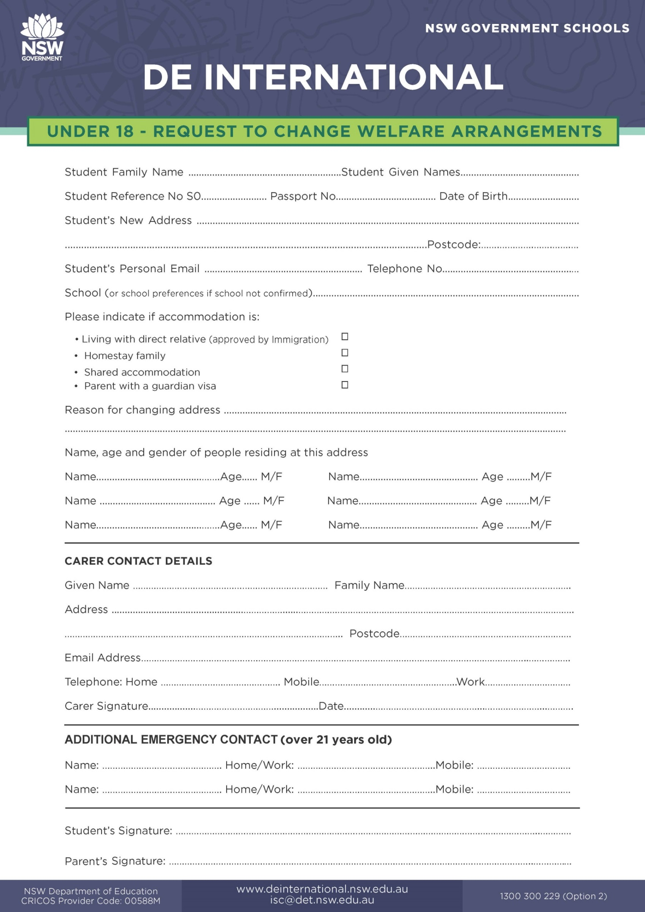

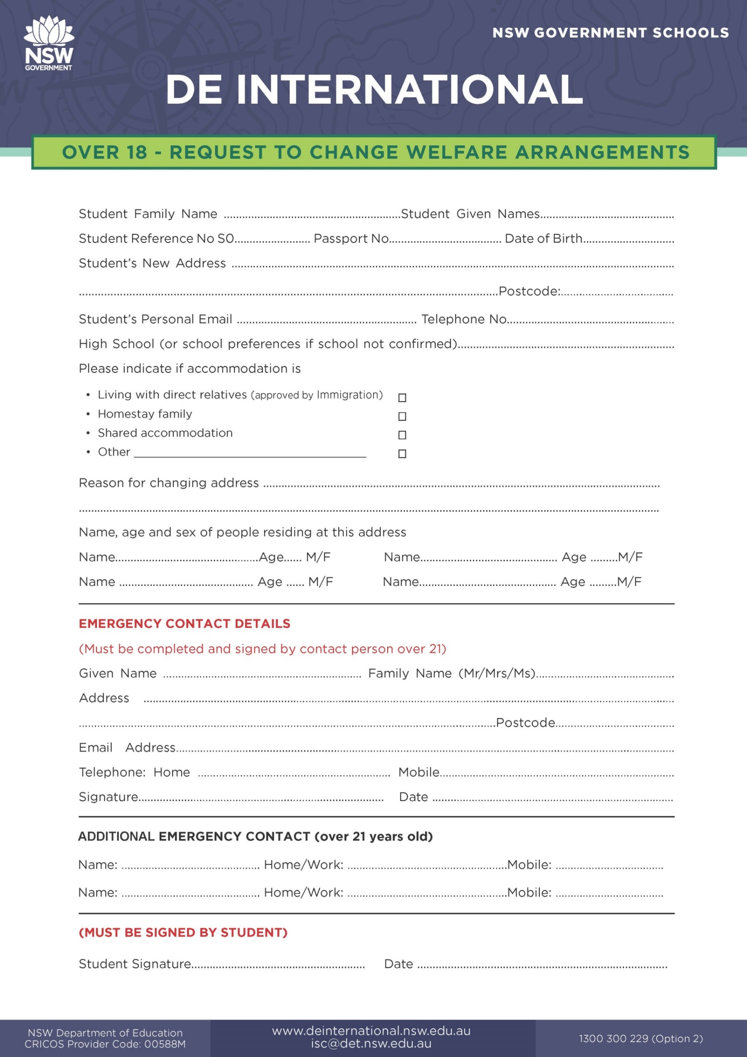

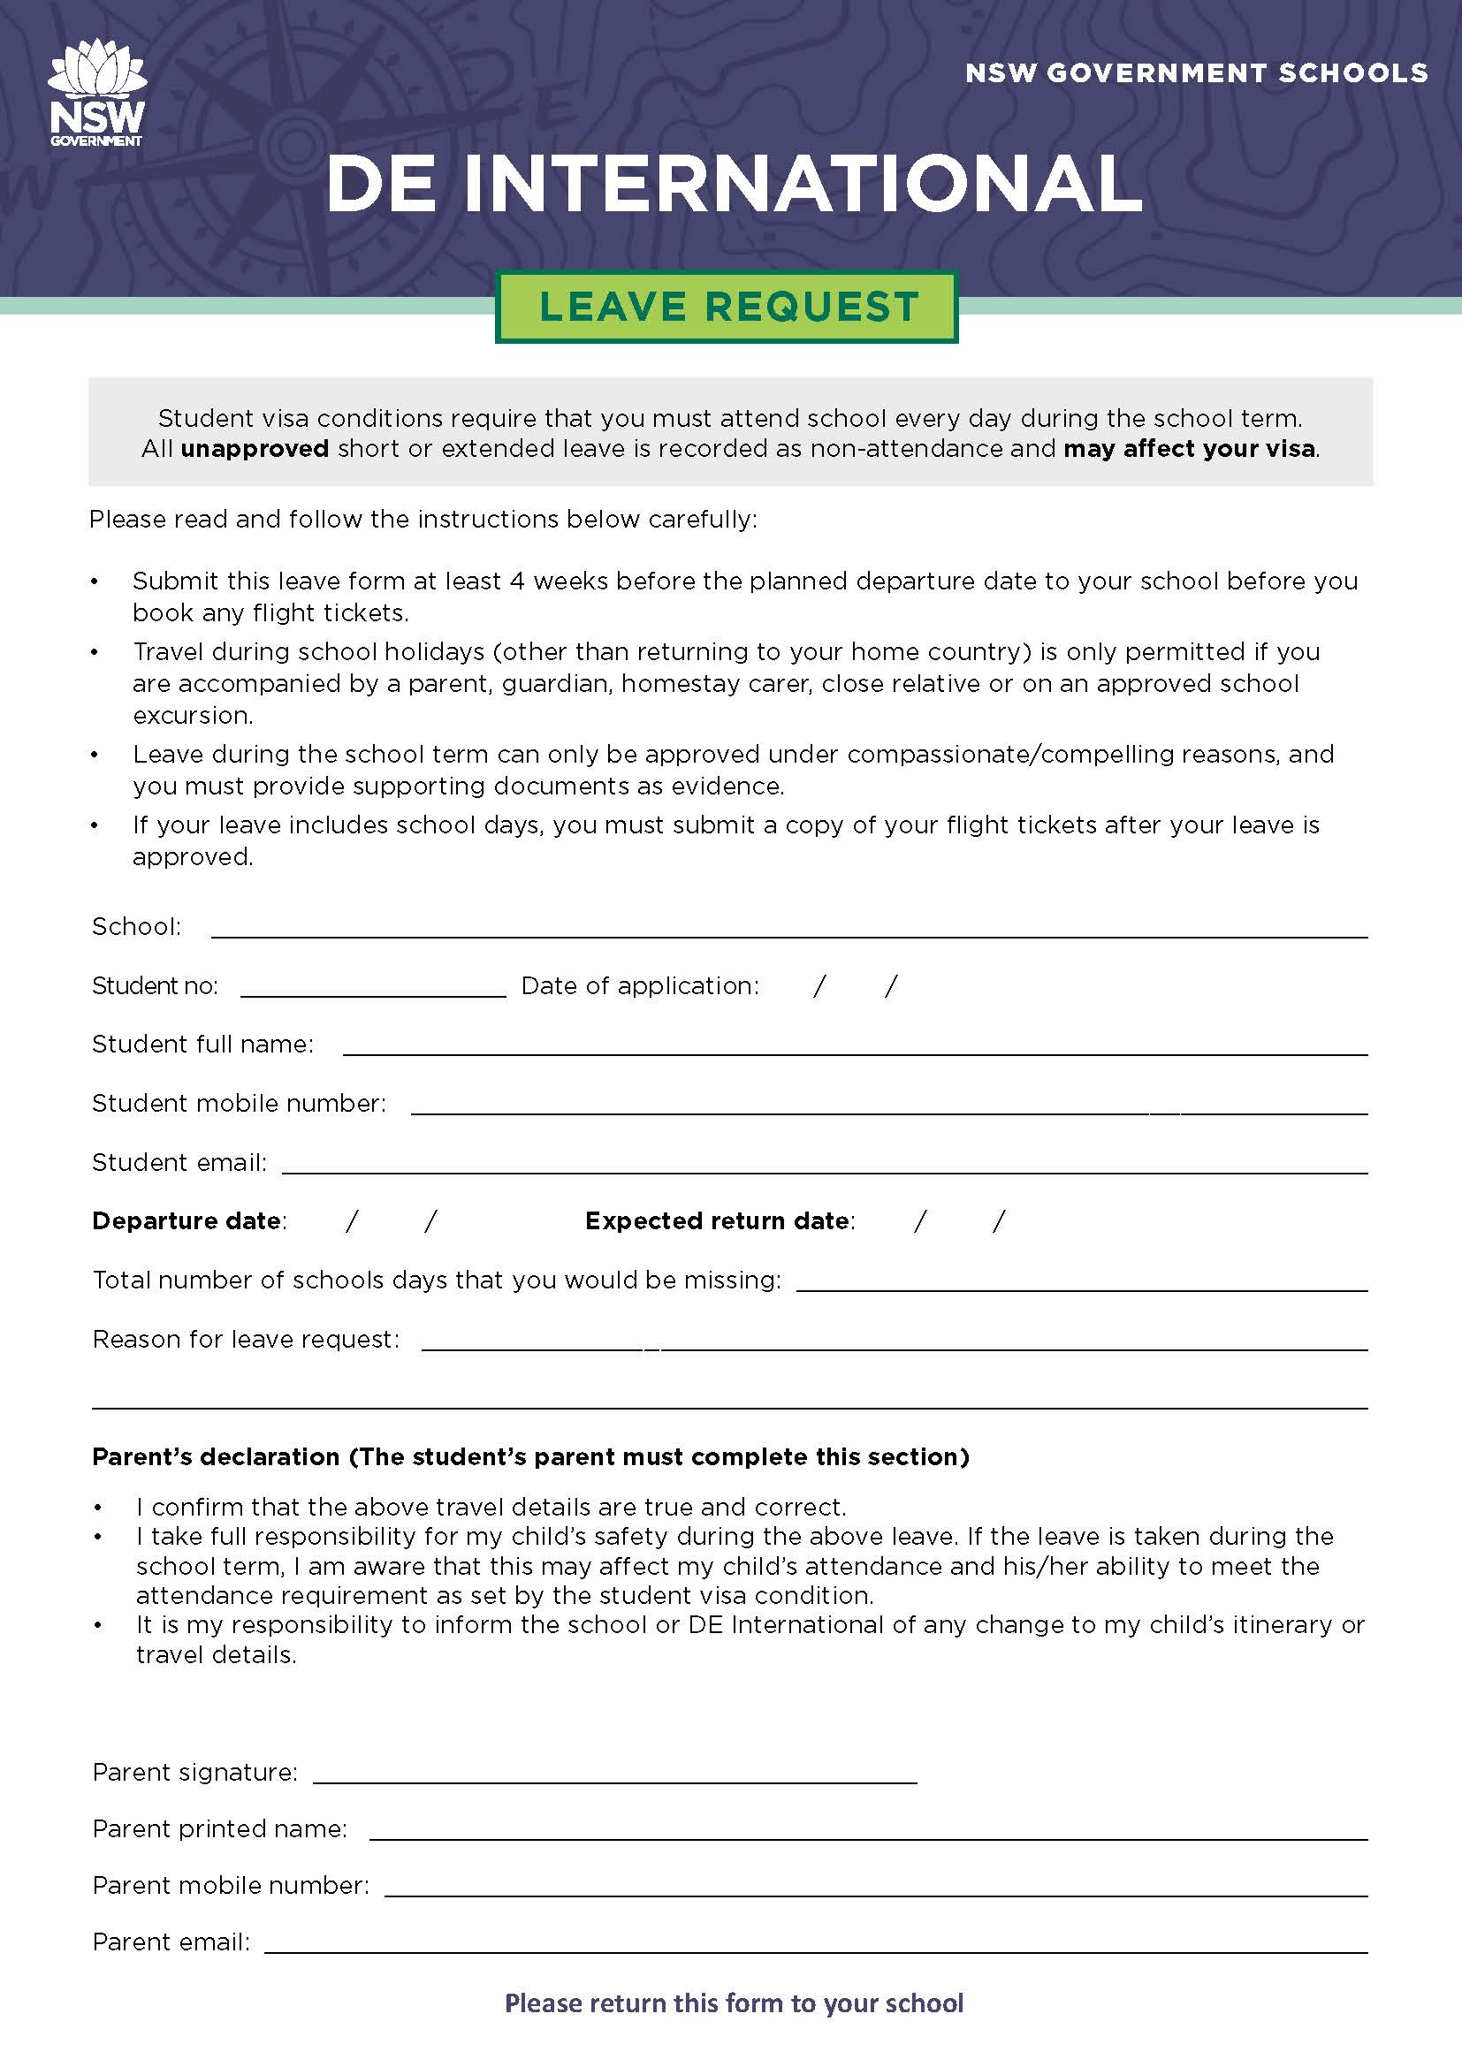Leave Requests Flow Chart

## Leave Requests Flowchart

The leave form must be signed by a parent

**STEP 1**

STEP 1

Submit completed form and any supporting documents to school

(International Student Coordinator)

**STEP 2**

STEP 1

School forwards request to DE International

**STEP 3**

STEP 1

DE International assesses request

**STEP 4**

STEP 1

**If approved:**

Purchase flight ticket and send a copy to school if your leave is taken during the school term

**If declined:**

Leave is not approved. Attendance will be affected if you leave school

|  |
| --- |
| **AUSTRALIAN NATIONAL ANTHEM**  Australians all let us rejoice,  For we are one and free;  We’ve golden soil and wealth for toil;  Our home is girt by sea;  Our land abounds in nature’s gifts  Of beauty rich and rare;  In history’s page, let every stage  Advance Australia Fair.  In joyful strains then let us sing,  Advance Australia Fair.  Beneath our radiant Southern Cross  We’ll toil with hearts and hands;  To make this Commonwealth of ours  Renowned of all the lands;  For those who’ve come across the seas  We’ve boundless plains to share;  With courage let us all combine  To Advance Australia Fair.  In joyful strains then let us sing,  Advance Australia Fair. |

